11 PSYCHOLOGY 2016

TEST TWO

Name: ____________________ Teacher: ___________________ Mark: /50

Percentage: %

Section One: Research methods (15 marks)

Question 1

State two disadvantages of collecting population data. (2 marks)

_____________________________________________________________________________________

_____________________________________________________________________________________

Question 2

Provide a psychological definition of ‘validity’. (2 marks)

_____________________________________________________________________________________

_____________________________________________________________________________________

_____________________________________________________________________________________

Question 3

Calculate the mode, mean, median and range for the following set of data. (4 marks)
(You do not need to show working out).

10, 13, 27, 17, 16, 15, 27, 27, 28, 24, 27, 15

a) Mode:

b) Mean:

c) Median:

d) Range:

Question 4

State the measure of central tendency that is most affected by extreme scores. (1 mark)
_____________________________________________________________________________________

Question 5

The table below shows the number of mobile phones owned by people in a population.
Ages | Mobile phones owned
10-14 | 3
15-19 | 2
20-24 | 6
25-29 | 7
30-34 | 5
35-39 | 2
40-44 | 5

State the most correct type of graph you would draw to represent this information and explain the reason for your choice of graph. (2 marks)

_____________________________________________________________________________________

_____________________________________________________________________________________

_____________________________________________________________________________________

Question 6
For the following scenarios, identify the operationalised independent variable and operationalised dependent variable.

a) Dr Woodford, a psychologist, was concerned about the levels of stress in local council employees. He wanted to investigate whether he could lower their stress levels, as measured by a self-report inventory, by medicating them daily with Clarinodroxyl. A control group completed the same inventory but did not take any of the medication. (2 marks)

Operationalised independent variable: _____________________________________________________

_____________________________________________________________________________________

Operationalised dependent variable: _______________________________________________________

_____________________________________________________________________________________

b) For his PhD, a university student investigates the effects of sleep deprivation on adults solving simple mathematical problems. He keeps Group 1 awake for 12 hours, Group 2 awake for 24 hours, Group 3 awake for 36 hours and Group 4 awake for 48 hours. He then gives all participants a series of basic arithmetic problems to solve. (2 marks)

Operationalised independent variable: _____________________________________________________

_____________________________________________________________________________________

Operationalised dependent variable: _______________________________________________________

_____________________________________________________________________________________

Section Two: Short answer (22 marks)

Question 7

Describe the location of the corpus callosum and state what its function is. (2 marks)

_____________________________________________________________________________________

_____________________________________________________________________________________

_____________________________________________________________________________________

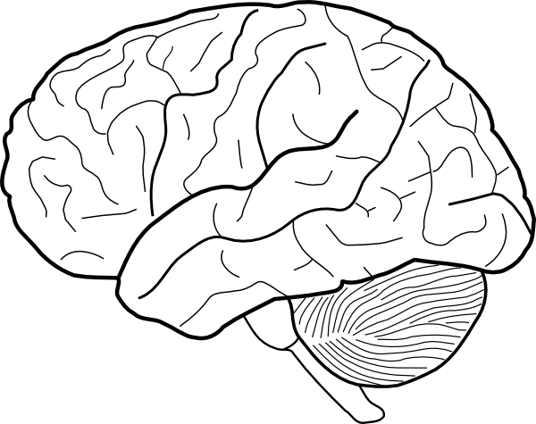
Question 8 (3 marks)

Look at the hemisphere shown in the diagram above. List three functions of this hemisphere.

_____________________________________________________________________________________

_____________________________________________________________________________________

Question 9

Complete the table below (2 marks)

Area damaged/injured | Impairment/impact of damage
Parietal lobe
 | Affects vision

Question 10

There are four lobes in each hemisphere of the brain. State the name of each lobe and state what it is mainly responsible for. (8 marks)

____________________________________________________________________________________

_____________________________________________________________________________________

____________________________________________________________________________________

_____________________________________________________________________________________

____________________________________________________________________________________

_____________________________________________________________________________________

____________________________________________________________________________________

_____________________________________________________________________________________

Question 11 (3 marks)

Complete the table below:

Function | Left or right hemisphere (L or R)
Reasoning
Creativity
Spoken language
Spatial orientation
Written skills
Scientific functions

Question 12

a) Label the diagram below. (3 marks)
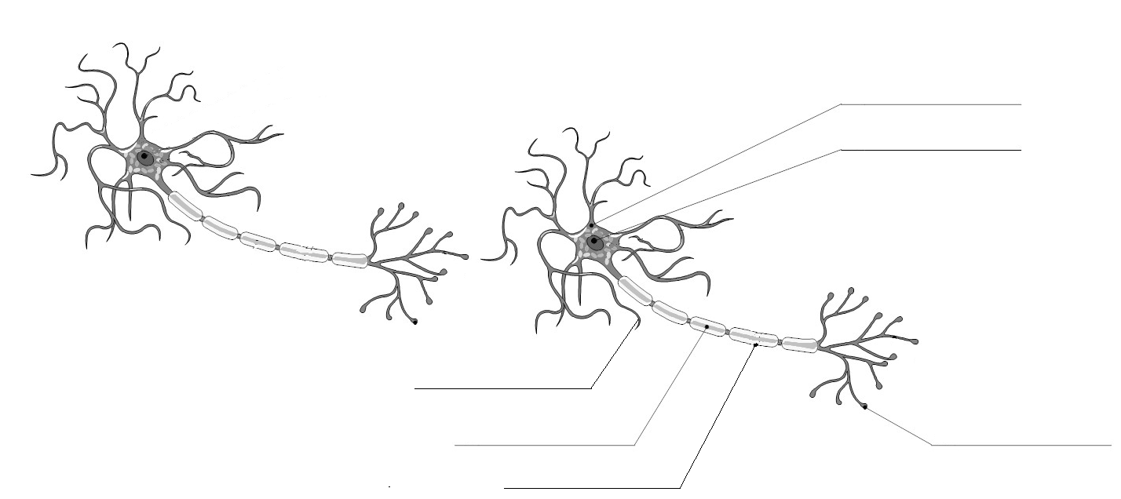
b) Draw arrows showing the path of a nerve impulse along/between the two neurons. (1 mark)
Section three: Extended answer (13 marks)

This section contains one (1) question that you must answer.

Pages are included at the end of the question for planning and writing your answer.
⬧ Planning: If you use a page for planning, indicate this clearly at the top of the page.
⬧ Answering the question: In the pages provided indicate clearly the section of the question you are
answering.

Suggested working time: 20 minutes.
_____________________________________________________________________________________

Question 13

Phineas Gage was a rail-way worker who suffered trauma to his brain when an iron rod was shot through his left check and out of the top of his skull, leaving part of his brain skewered. His story is one of the earliest cases of brain injury to be used in studies.
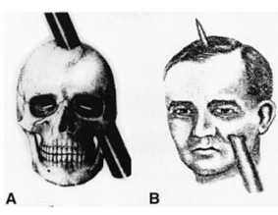

In your response:
- State the area of brain that was damaged from the injury
- Describe the effects this trauma had on Phineas Gage
- Describe how this type of injury is similar in people who have had a stroke
_____________________________________________________________________________________

_____________________________________________________________________________________

_____________________________________________________________________________________

_____________________________________________________________________________________

_____________________________________________________________________________________

_____________________________________________________________________________________

_____________________________________________________________________________________

_____________________________________________________________________________________

_____________________________________________________________________________________

_____________________________________________________________________________________

_____________________________________________________________________________________

_____________________________________________________________________________________

_____________________________________________________________________________________

_____________________________________________________________________________________

_____________________________________________________________________________________
_____________________________________________________________________________________

_____________________________________________________________________________________

_____________________________________________________________________________________

_____________________________________________________________________________________

_____________________________________________________________________________________

_____________________________________________________________________________________

_____________________________________________________________________________________

_____________________________________________________________________________________

_____________________________________________________________________________________

_____________________________________________________________________________________

_____________________________________________________________________________________

_____________________________________________________________________________________

_____________________________________________________________________________________

_____________________________________________________________________________________

_____________________________________________________________________________________

_____________________________________________________________________________________

_____________________________________________________________________________________

_____________________________________________________________________________________

_____________________________________________________________________________________

_____________________________________________________________________________________

_____________________________________________________________________________________

_____________________________________________________________________________________

_____________________________________________________________________________________

_____________________________________________________________________________________

_____________________________________________________________________________________

_____________________________________________________________________________________

_____________________________________________________________________________________
_____________________________________________________________________________________

_____________________________________________________________________________________

_____________________________________________________________________________________

_____________________________________________________________________________________

_____________________________________________________________________________________

_____________________________________________________________________________________

_____________________________________________________________________________________

_____________________________________________________________________________________

_____________________________________________________________________________________

_____________________________________________________________________________________

_____________________________________________________________________________________

_____________________________________________________________________________________

_____________________________________________________________________________________

_____________________________________________________________________________________

_____________________________________________________________________________________

_____________________________________________________________________________________

_____________________________________________________________________________________

_____________________________________________________________________________________

_____________________________________________________________________________________

_____________________________________________________________________________________

_____________________________________________________________________________________

END OF RESPONSE

